 ***SOFTWARE REQUIREMENTS SPECIFICATIONS DOCUMENT***

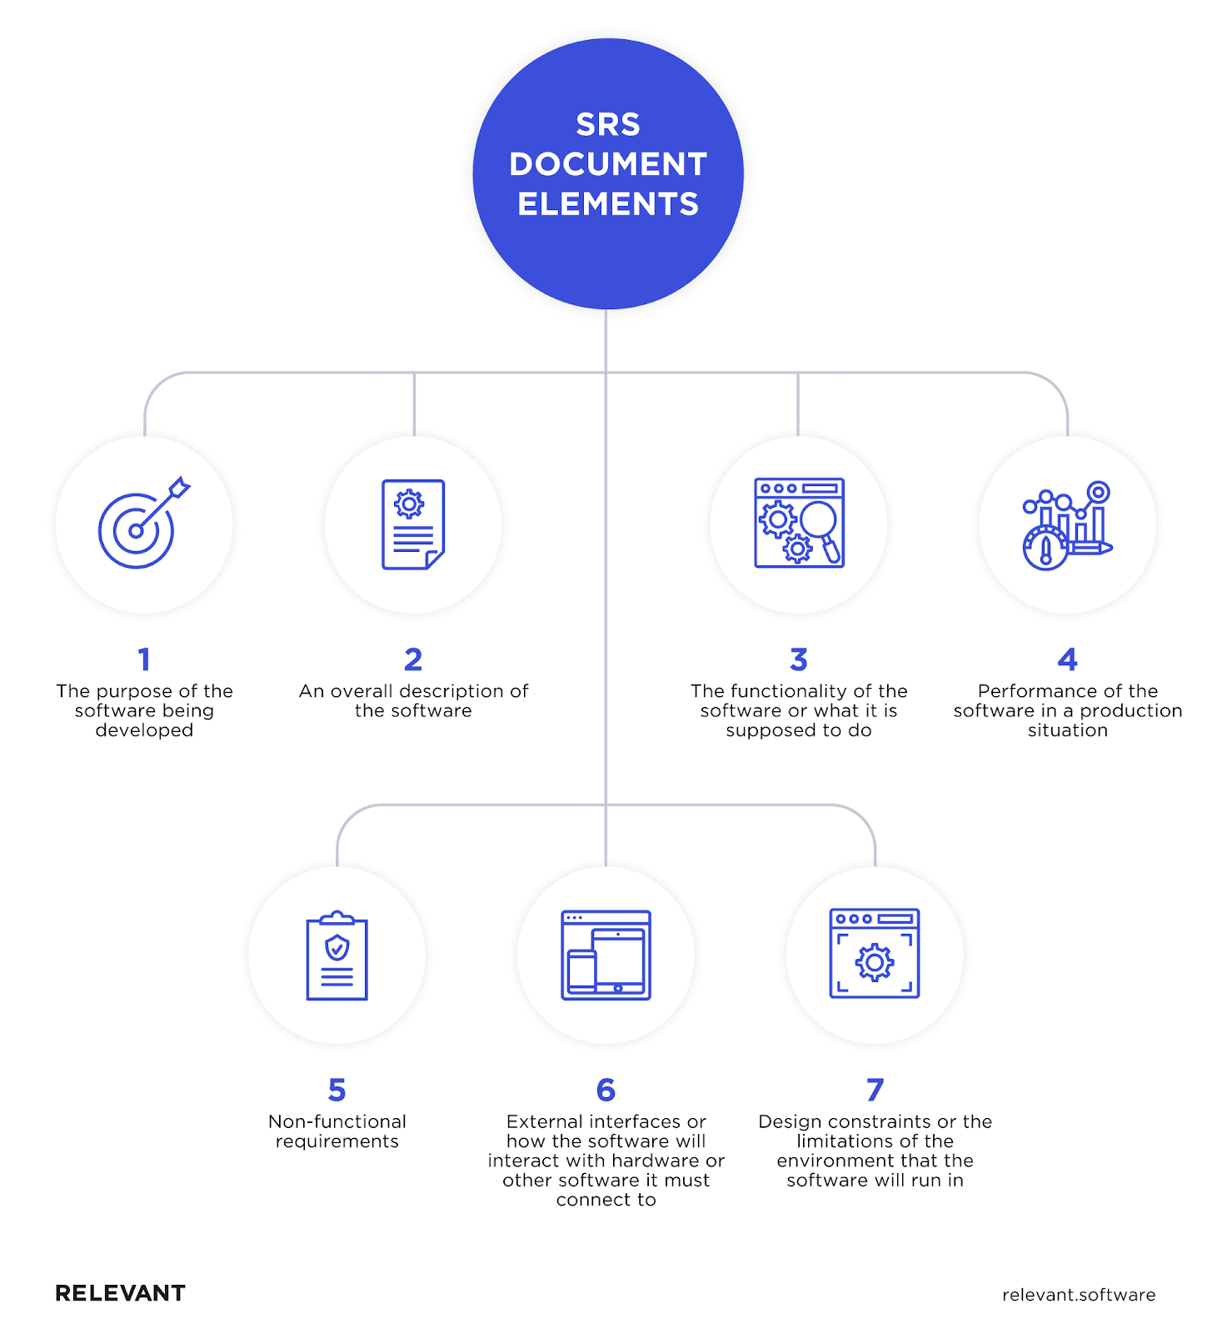

***Introduction:***

Meet JobVengers – your friendly job-hunting sidekick. JobVengers makes finding a job easy and fun. It's like having your own superhero team for your career. We find jobs that match what you're good at and make the whole job search thing simple. Your dream job is out there, and JobVengers is here to help you find it!

***Purpose:***

JobVengers is here to help you find a job that fits your skills and dreams. We make job searching easy and connect you with opportunities that matter. Our goal is to make your career journey simple and enjoyable. Join us to discover a world of job possibilities and success!

***Intended Audience:***

JobVengers is designed for individuals of all backgrounds and experiences who are on the lookout for their next career move. Whether you're a recent graduate, seasoned professional, career changer, or someone exploring new opportunities, JobVengers is your go-to platform.

***App features:***

* Sign up

1. As a job seeker
2. As an employer

* Login in
* Job post
* Job search
* Filter for searching job
* Communication through messages
* Exchange document in form

***User Registration and Login:***

Users can easily sign up as either job seekers or employers.

Secure login feature to access personalized profiles.

Job Seeker Features:

***Job Search:***

Effortlessly search for job opportunities based on keywords, location, or job categories.

Explore a vast array of job listings from various industries.

***Filter Options:***

Implement filters for specific job categories, such as Python Developer or React Developer, to tailor job searches to individual preferences.

Employee Features:

***Job Posting:***

Employers can create and post job openings, providing detailed descriptions of the positions available.

Include specific job requirements, responsibilities, and company information.

***User Profiles:***

Detailed profiles for both job seekers and employers, showcasing skills, experience, and relevant details.

Job seekers can upload resumes in pdf form.

***Communication Platform:***

In-app messaging system for seamless communication between job seekers and employers.

Intuitive and user-friendly design for easy navigation, ensuring a positive user experience.

***Analytics Dashboard:***

Provide both job seekers and employers with analytics on application statuses, job views, and other relevant metrics.

***Technologies:***

* **Frontend - Kotlin:**

Kotlin is a programming language that will be use for developing our Android applications. It is concise, expressive, and interoperable with Java, making it a popular choice for building frontend applications.

* **Backend - PHP:**

For backend PHP will be use. PHP is a server-side scripting language. PHP is often integrated with databases and can handle various server-side tasks.

* **UI/UX Design - Figma:**

Figma is a cloud-based design tool used for creating user interfaces (UI) and user experience (UX) designs. It allows multiple team members to collaborate in real-time on the design process and is popular for its ease of use and collaborative features.

***Functional requirements:***

***User Registration and Login:***

Users can register as job seekers or employers.

Secure login functionality to access personalized profiles.

*Job Seeker Features:*

* ***Job Search:***

Implement a search bar allowing users to search for job opportunities using keywords, location, or job categories.

* *Filter Options:*

Enable users to filter job searches based on specific categories, such as Python Developer or React Developer.

***Employer Features:***

* ***Job Posting:***

Create a user-friendly interface for employers to post job openings with detailed descriptions, requirements, responsibilities, and company information.

* ***Resume Upload:***

Allow job seekers to upload their resumes in PDF format for employers to review.

**User Profiles:**

**Communication Platform:**

* ***In-App Messaging:***

Implement an in-app messaging system for seamless communication between job seekers and employers.

***Non-Functional requirements:***

***User Interface:***

**Intuitive Design:**

Design a user-friendly interface ensuring easy navigation and a positive user experience.

***Analytics Dashboard:***

Provide analytics for both job seekers and employers, including application statuses, job views, and other relevant metrics.

***Performance:***

Ensure that the app responds quickly to user actions, with minimal latency in loading job listings and profiles.

***Scalability:***

Design the app to scale efficiently to accommodate a growing user base and increased job postings.

Implement a scalable database architecture to handle a growing number of user profiles, job listings, and interactions.

***Reliability:***

Aim for high system availability, minimizing downtime to ensure users can access the app reliably.

***Security:***

Implement robust data encryption protocols to secure user data and protect sensitive information.

Ensure secure user authentication and authorization processes to prevent unauthorized access.

***Accessibility:***

Design the app interface to be accessible to users with disabilities, following best practices for inclusive design.

***Maintainability:***

Develop clean, modular, and well-documented code to facilitate ease of maintenance and future updates.

***Privacy:***

Adhere to data privacy regulations and standards to protect user privacy and build trust.